**GENERIC ELECTIVE – 4**

**(OPEN SOURCE SOFTWARE)**

**Teacher: - Prof. Suparna Bora, Dept. of Computer Science & Engg.**

**ASSIGNMENT – 7.1**

**TOPIC- PYTHON PROGRAMMING**

**Prepared by- Name: - RAJDEEP DAS**

**Roll No. - 202151027**

**Course: - B.Sc. (H) Biotechnology,**

**2nd Semester**

**PROGRAM ON PRODUCT OF TWO INTEGERS**

**Question: - Calculate the product of two integers. If the product is greater than 1200, then return their sum else return their difference.**

**Answer:-**

**Input:-**

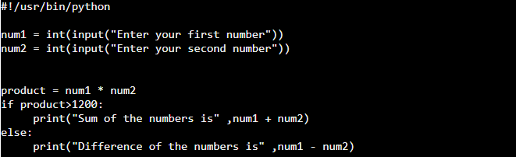

**Output:-**

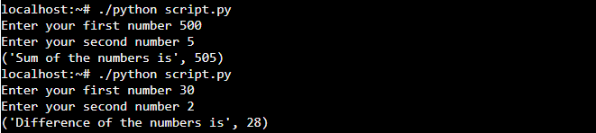

In this case, the code has been run once for <1200 & once for >1200.